
INTRODUCTION TO DATA MANAGEMENT
PROJECT REPORT
(Project Semester August-December 2018)
COUNTRIES OF THE WORLD

Submitted by
ASHISH LEPCHA
Registration No 11603969
Programme :B-tech CSE
Section: KEM39
Course Code: INT217

Under the Guidance of
SAVLEEN KAUR

Discipline of CSE/IT

Lovely School of Computer Science and Engineering

Lovely Professional University, Phagwara

CERTIFICATE

This is to certify that Ashish Lepcha bearing Registration no.11603969 has completed INT217 project titled, “countries of the world” under my guidance and supervision. To the best of my knowledge, the present work is the result of his/her original development, effort and study.

Signature and Name of the Supervisor:
Designation of the Supervisor:
School of Computer science and technology.
Lovely Professional University
Phagwara, Punjab.

Date: 18/11/2018

DECLARATION
I, Ashish Lepcha, student of B-tech computer science technology under CSE/IT Discipline at, Lovely Professional University, Punjab, hereby declare that all the information furnished in this project report is based on my own intensive work and is genuine.

Date: 18/11/2018 Signature:
Registration No:11603969 Ashish Lepcha.

TABLE CONTENT

- Introduction
- Scope of the Analysis
- Existing System
- Drawbacks or limitations of existing system
- Source of dataset
- ETL process
- Analysis on dataset (for each analysis)
- Introduction
- General Description
- Specific Requirements, functions and formulas
- Analysis results
- Visualization
- List of Analysis with results
- Future scope
- Reference

INTRODUCTION

This project is based on the use of Microsoft Excel software. In this project we use all the necessary methods and technique which we learned in the class. This project helps us to understand and visualize the problem and analysis from the dataset we extracted from our respective resources.
This project deals with the dataset of the countries of the worlds, where we try to extract enough information from it using various excel tools. We follow the Extract Transformation and Loading procedure which can be abbreviated as ETL. ETL process first we extract data for the source and maintain it in a date base or excel sheet and store it for future usage. After this phase we move to transformation phase where we wrangle the data which means cleaning of data. As we know when we extract data from the source it is raw and not filtered and there could be lots of unambiguous values which will lead to error result in the future.
These values need to be replaced or removed for the data to clean. We prepare the data for next process which is loading. Loading is a phase where we analyze the data and get some meaningful result out of it. It consists of various visualization methodology and creating a dashboard where an audience can easily depict a story from the analysis result presented in a visual way thought different graph, charts and maps.
Here we can clearly understand how a country growth is dependent on various factors such as industries, population, agriculture, area of the region. The dataset used in this analysis is extracted from Kaggle website. Kaggle website contains different kinds of dataset and hosts competitions.
Some of the functions used for the analysis are pivot tables, charts, hyperlinks, maps, pivot charts, basic mathematical functions and in-built functions. We use Excel 2016 for the analysis.

SCOPE OF THE ANALYSIS

- This project tries to give a clear picture of the demography, industries and agricultural conditions of different regions of the world by analyzing all the data from all the countries falling in the specific region.
- We get to learning the process of cleaning the data and maintaining it in excel sheets.
- We learned about countries GDP and their industrial growth.
- Growth in the production of crops depending upon the climate and arable conditions.
- Literacy rate of each countries and usage of phones per 1000.
- Variation in the birth rate, death rate and infant immortality rate.
- The expand of the area of a region and their industries.
- Creating an interactive dashboard to display the result of the analysis in a pictorial format.

EXISTING SYSTEM

We can use excel up to certain level but as the size data increases analyzing becomes difficult so we opt for other software or methods. There are lots of complex meters and structure to visualize which are not understood by the normal people. The main idea is to create a dashboard which simple yet versatile in projecting its ideas to the audience.

Drawbacks of the existing system:

We are dealing with data which need to be visualized rather than understanding from the data. We need to create as simple dashboard as possible which is enough to convey the idea of the analysis. Some of the problem faced while using excel software are as follows:
- Only useful specific size of dataset.
- It is very slow and hectic process.
- Working on excel is like working on very limited-scaled tables.
- Very slow with bigger data sets.
- Detailed visualization is not possible.
- Excel is susceptible to human error.
- Lack of control and security.
- Referencing is confusing and tedious.
- Maintaining different sheet with data on it can be difficult.
- Without the add-in Excel is time consuming and primitive compare to other data analysis tool.
- Statistical analysis is very difficult.
- System compatibility might be an issue with some operating system.

SOURCE OF DATASET

The dataset used in this project is extracted from kaggle.com .In Kaggle we can find different dataset and use them to analyze and extract some useful information from the dataset.

Link to the dataset: https://www.kaggle.com/fernandol/countries-of-the-world.

ETL PROCESS (Extract, transformation, Loading)

Extract:
- We extract the data from our desired source as in my case I downloaded my data from Kaggle website.
- The name of my data is ’countries of the world’.
- Though the dataset consisted of lot of unambiguous values.
- I made a clear picture in my head for using the data further.
- The data was in .csv(comma separated value) format so for me to load in excel I converted it to .xls (Microsoft excel sheet) format.
- After the extraction of the data is completed I moved on to the next phase
which is transformation.

Transformation:
- cleaning and shaping our data was my next task, I quickly scanned the data and found some blank cell and unambiguous values (like NaN (not a number ),two values in single cell separated by comas etc).
- First thing is to fill all the blank cell, I was the built-in find and replace option from the top ribbon of the excel and replaced all the blank values with zeros.
- Now my next challenge is to get single values from two different values separated with comas on closely observing the pattern of the number given we see they are in range of first and last number so we do the difference of the numbers and get the resultant value.
- Some columns are dropdown because their significance was least important, only the weighted columns are sorted out for further analyzing.
- After analyzing the data we tend to require more broader way of presenting the result so we jump to loading phase.

Loading:
- This is the storytelling phase where we present the result of the analysis in pictorial representation for the audience to get the clear idea of the analysis outcome.
- Excel provides various tools for visualization.
- We use pivot table to represent certain set of data from the main data and visualize it using different charts.
- We create different charts graph and map and control their variations using slicers and timeline.
- All charts are represented in one sheet and this is what we called a dashboard, where we can visually see the change and growth in their structure with the help of visual aid in the form of graphs and charts.

ANALYSIS OF THE DATASET

My objectives of analysis are as follows:
- GDP of the different regions
- Area covered by the region.
- Population density and birth and death rate.
- Agriculture development.
- Economic development.

- Analysis of GDP of the different regions
Introduction
This analysis mainly focuses on the GDP of the different regions according to their population density and their resources. Regions with higher agriculture development and industries tend to have higher GDP compare to other regions.

General description
- We first analyze the dataset for related values.
- We create a pivot table containing the GDP values of different region.
- We try to visualize it using different charts.
- We use bar chart to visualize the GDP.
- We can easily pick the region with the highest GDP.
- After this we can check its population and area for further analysis

Specific requirements
- Excel 2013 or later.
- Good knowledge about pivot table and charts and basic formulas like sum, add, multiply and divide.
Analysis result
- We can see that GDP is directional proportional to population density and industries.
- More the resource it can produce more will be the GDP.
- Area is indirectly related to the regions GDP.
- Each country constitutes in regions GDP.
Visualization
.
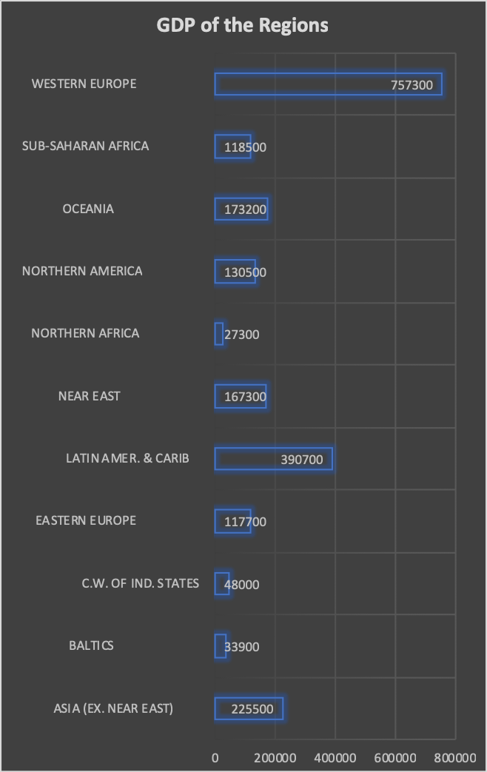

- Analysis of Area of the different regions
Introduction
The most important possession that a region can have is the area where all agriculture and industries can me started can build. Area plays a major role in population growth.
General description
- We use pivot table a pie chart to see the region with larger area.
- We create a pivot table just by using regions and area.
- We can also evaluate population density by dividing the area by population.
- We can get the clear visual picture of the region with large area
- Agriculture is also dependent on area of a region.
Specific requirements
- Excel 2010 or later.
- Knowledge about pivot table and charts.
Analysis result
- We get to see the region with the largest way through the pie chart created using pivot table.
- We can all the values dependent on the are directly or indirectly.
Visualization

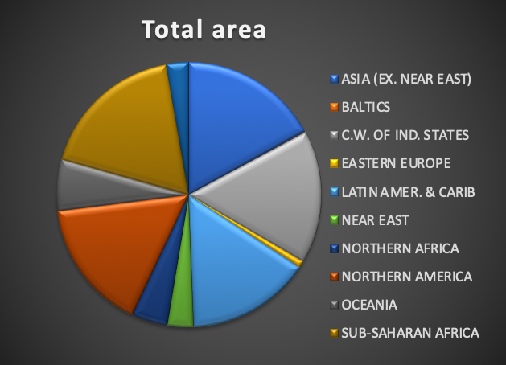

- Analysis of Agricultural development of the different regions

Introduction
Agricultural development is a key factor that help the country to boost up their GDP. It can dependent on various factors area, arable rate, climate, number of crops produce. Our task is to find the region which is best suitable for agriculture and compare its GDP and area to see does it relate to development of the country.
General description
      - We evaluate the agricultural development taking three criteria mainly agricultural, arable rate, crops produce.
      - We create a pivot table based on these values.
      - We add these values to the pivot chart and create a visual of agricultural growth.
      - We use line plot to show these three variations.
      - We use another map plot to show area having higher agriculture.
Specific requirements
      - Excel 2010 or later.
      - Some useful logics functions such as SUMIFS (it handles all the possible conditions), SUMIF ().
      - Knowledge about pivot table and charts.
Analysis result
      - We can see the variation with the three variable and how they are related to each other.
      - We can compare the GDP of the country or region with the agricultural development.
      - We can also relate with the area of a region. Even if the country having high arable rate but less area their agricultural is affected drastically.

Visualization
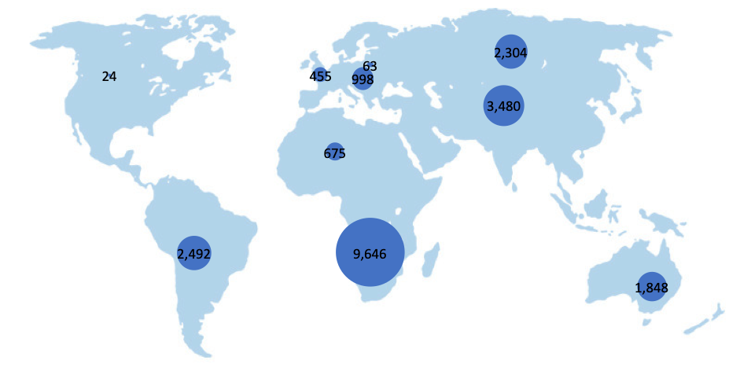

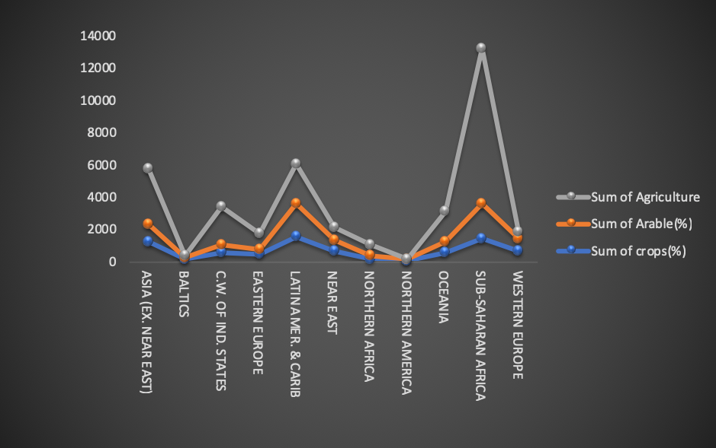

- Analysis of population growth of the different regions
Introduction
Ever country or region has a capacity for population, any region crossing this capacity is regarded as overpopulated. Area is directly affected by the increase in population. We are still trying to curb the population growth in different regions by implementing laws and rules. Here we will try to visualize the most populated region and decide is it overpopulated or not. We will visualize the birth and the death rate and infant immortality for further illustration.
General description
      - Population playing an important part in a countries GDP, we need to carefully pick our region with the highest population.
      - We calculate population density using the area and the population of the country or region.
      - We create pivot table for the given values and try to provide a clear visualization for the population.
      - We plot a bar chart for the death and birth rate and infant immortality.
Specific requirements
      - Excel 2010 or later.
      - We make use of simple logical function like sum, divide, find and replace, text to column.
Analysis result
      - We can see that the Asia is the region with the highest population having to of the most populated countries China and India.
      - Even though they have fair amount of area still the population is struggling.
      - It will affect the economic development of the county.
      - Unemployment rate will increase.
      - Countries with lower death rate are prone to overpopulation.

Visualization

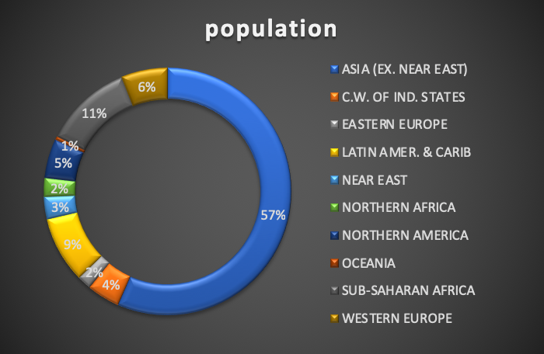

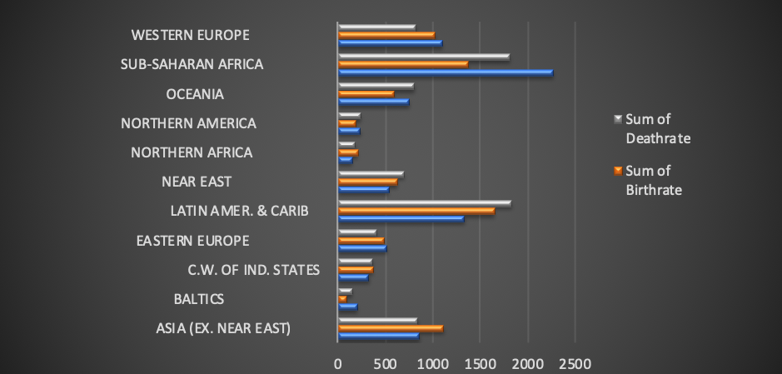

- Analysis of Economic development of the different regions
Introduction
This is the most crucial analysis of this dataset as it is inter-related with all the analysis. The main idea behind the economic development is the growth of overall countries GDP, agriculture, industries and resources. Economic development of the countries is linearly dependent on these factors and individual population growth.
Some of the other factors are literacy rate, phones per thousands, agriculture.
Economic development and improvement can make a country financially stable and their GDP will gradually increase which will lead to development of the country and help to pave way for future generations.
General description
      - Analysis is done using various data and comparing and inter-relating them.
      - We create a simple pivot table using literacy and industries and compare the output.
      - We can clearly see that literacy rate and industries corelate with each other.
      - We plot a column cart to visualize the outcome of the analysis.
Specific requirements
      - We use excel 2010 or later.
      - Pivot table and charts
      - Simple formulas to calculate the sum, divide etc.
      - We use a function ABS () to remove all the negative sign from the data set while extracting values for the columns.
      - We use text to column option from the top ribbon to separate values in a single row separated by commas into separate columns.
Analysis result
      - We observe that the countries with higher GDP has higher usage of phones and the number of industries and literacy is more.
      - We can see from the third visualization that countries with higher agriculture doesn’t have to have high GDP.
      - Literacy rate help in development of the industries and increase employment.
      - It can help to curb the overpopulation, as it is easier to make then understand about controlling overpopulation.
      - We can end our analysis with a keynote that economic development cannot be achieved in a short time of span, it needs years of improvement in different aspects of the countries environment and understanding their problems and finding best possible solution.

Visualization

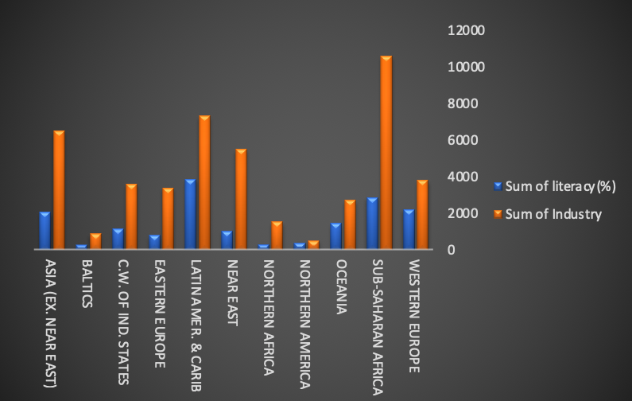

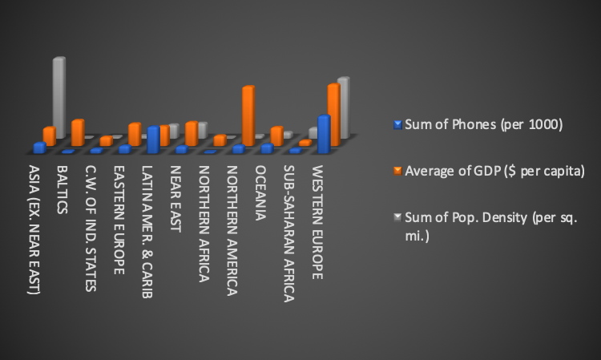

LIST OF ANALYSIS WITH RESULT

- GDP of the different regions
  - Analysis result
- We can see that GDP is directional proportional to population density and industries.
- More the resource it can produce more will be the GDP.
- Area is indirectly related to the regions GDP.
- Each country constitutes in regions GDP.

- Area under the region.
  - Analysis result
- We get to see the region with the largest way through the pie chart created using pivot table.
We can all the values dependent on the are directly or indirectly
- Population density and birth and death rate.
  - Analysis result
      - We can see the variation with the three variable and how they are related to each other.
      - We can compare the GDP of the country or region with the agricultural development.
      - We can also relate with the area of a region. Even if the country having high arable rate but less area their agricultural is affected drastically.
- Agriculture development.
  - Analysis result
      - We can see that the Asia is the region with the highest population having to of the most populated countries China and India.
      - Even though they have fair amount of area still the population is struggling.
      - It will affect the economic development of the county.
      - Unemployment rate will increase.
      - Countries with lower death rate are prone to overpopulation.

- Economic development.
  - Analysis result
      - We observe that the countries with higher GDP has higher usage of phones and the number of industries and literacy is more.
      - We can see from the third visualization that countries with higher agriculture doesn’t have to have high GDP.
      - Literacy rate help in development of the industries and increase employment.
      - It can help to curb the overpopulation, as it is easier to make then understand about controlling overpopulation.

FUTURE SCOPE

- This analysis helps to predict the future increase in the GDP of the regions.
- IT can pin point the demographic variation in the death and birth rate.
- This dataset contains data collects from years of evaluations and storing which might not be the same in current but still we compare any go with the small change.
- Change in population can be tracked.
- Though this dataset is incomplete because of the missing timeline values which is very essential for evaluating the time series.
- This dataset should be updated yearly for more accurate predictions.
- We can track the economic development of the country and regions.
- Agricultural growth can be measured.
- This dataset can be utilized with different analysis software to predict a countries development and how a country can affect the overall all growth of the country.

Reference

- http://Youtube.com/
- https://www.kaggle.com/
- https://digital.com/blog/excel-tutorials/
- https://support.office.com/en-us/article/excel-for-windows-training-9bc05390-e94c-46af-a5b3-d7c22f6990bb

